Slice App sentiment report

# Overall Summary

* App name: Slice
* Number of reviews analyzed is 29,303
* Total number of reviews after cleaning the data is 20,054
* Timeline of reviews: 1 January,2020 to 21 January,2021 (386 days)

## Comparison of Aspects depending on how many numbers of people are writing about the aspect.

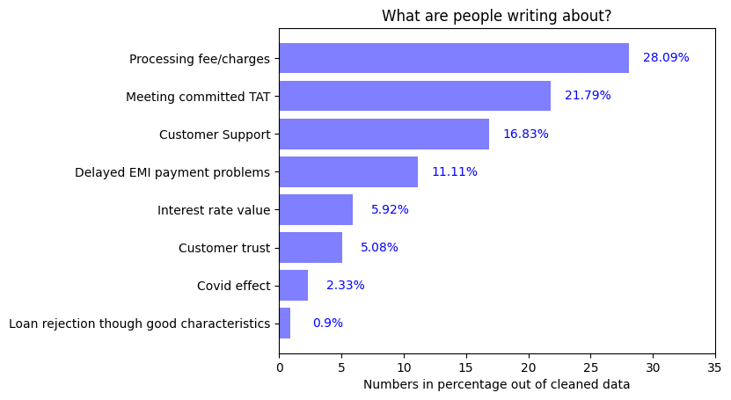

## Comparison of Aspects depending upon average rating given by users:

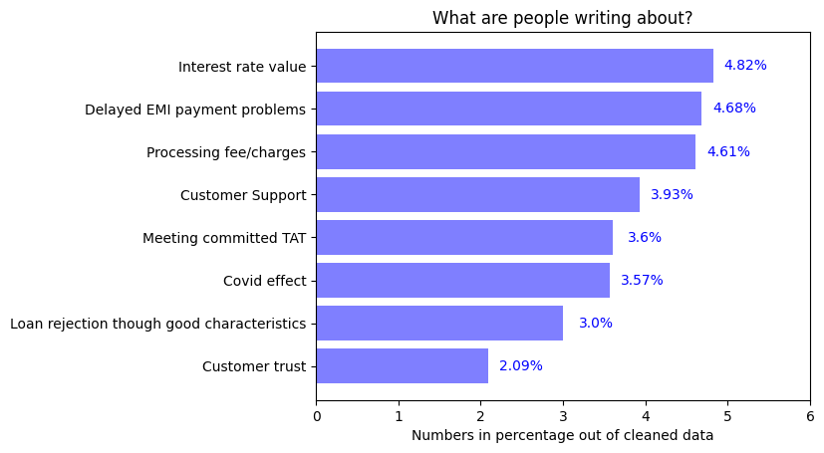

### Inference:

1. Large number of people are writing about meeting committed TAT, Processing fee and Customer support so these are important points from users’ perspective
2. The main selling point of this app is charge-free credit card which is why lot of people are writing about processing fee/charges

# 1.Appropriate Interest rate

* 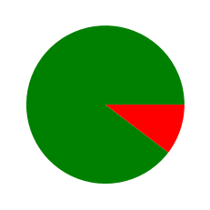Percentage of people writing about this topic is 5.92%
* Average rating given by users for this aspect is 4.82 out of 5
* 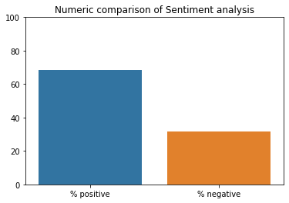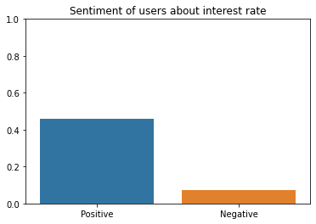Sentiment Analysis:

Figure 2: This shows how many people are positive or negative about this aspect

Figure 1: This shows Intensity of negativity or positivity of sentiments

### Inference:

1. People are more positive than negative about interest rate
2. Large number of people are Positive about interest rate and it matches the industry standards

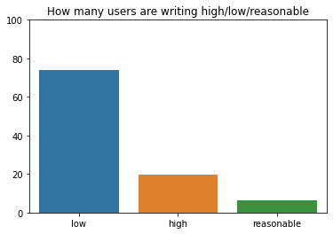Further Insights:

People saying interest rate is low =74.04%

People saying interest rate is high=19.46%

People saying interest rate is reasonable=6.48%

# 2.Delayed payments of EMI

* Percentage of people writing about this topic is 11.11%

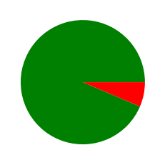

* Average rating given by users is 4.68 out of 5
* 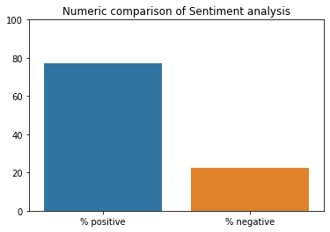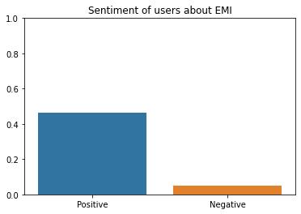Sentiment Analysis:

Figure 2: This shows how many people are positive or negative about this aspect

Figure 1: This shows Intensity of negativity or positivity of sentiments

### Inference

1. Unlike other apps, this has surprisingly high rating for delayed installment payments problems, which a notable achievement
2. Possible reasons:
   1. Provides Zero maintenance charge credit card which is very popular comment

# 3. Loan rejection though good characteristics

* Percentage of people writing about this topic is 0.9%



* Average rating given by users is 3.00 out of 5
* 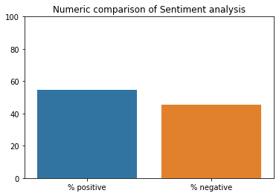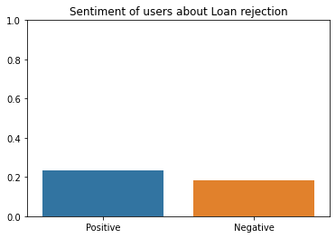Sentiment analysis:

Figure 2: This shows how many people are positive or negative about this aspect

Figure 1: This shows Intensity of negativity or positivity of sentiments

### Inference:

1. The sentiment of users about this aspect is positive
2. And, the number of users writing about this topic are also very low
3. The app has done good job with respect to this aspect

# 4. Customer queries / grievances support services:

* Percentage of users writing about this topic is 16.88%

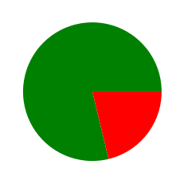

* Average rating for Customer support is 3.93 out of 5
* 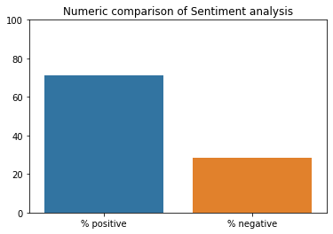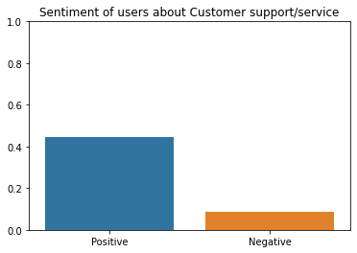Sentiment Analysis:

Figure 2: This shows how many people are positive or negative about this aspect

Figure 1: This shows Intensity of negativity or positivity of sentiments

### Inference:

1. Users are more positive about Customer support
2. Almost 16% of users are writing about this aspect

# 5.Processing Fee/ Extra Charges:

* Percentage of People writing about this topic is 28.09%

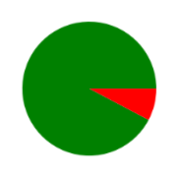

* Average rating for this topic = 4.61 out of 5
* 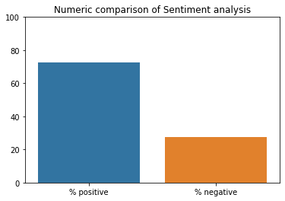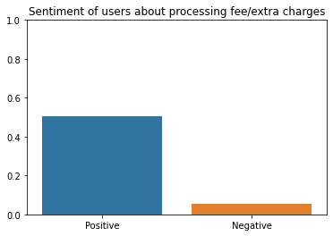Sentiment:

Figure 2: This shows how many people are positive or negative about this aspect

Figure 1: This shows Intensity of negativity or positivity of sentiments

### Inference:

1. Users are completely satisfied with charges and this is the main selling point of this app
2. Possible reasons:
   1. Zero charge credit card
   2. Giving services to young students
   3. The card can be used for online shopping

# 6. Loan disbursal to customer meeting the committed TAT

* Percentage of users writing about this topic is 21.79%



* Average rating by users is 3.60 out of 5
* 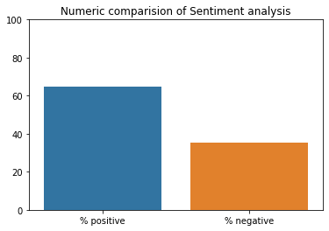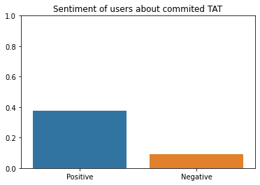Sentiment:

Figure 2: This shows how many people are positive or negative about this aspect

Figure 1: This shows Intensity of negativity or positivity of sentiments

### Inference:

1. Sentiment of users about TAT is mostly positive
2. As they provide card directly, TAT reduced drastically
3. Large number of users are writing about this topic and the cumulative sentiment is negative
4. Almost 20% of users have written about this aspect

# 7.Trust / legal/ fraud issues with app

* Percentage of users writing about this topic is 5.08%



* Average rating by these users is 2.09 out of 5
* 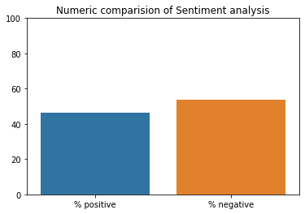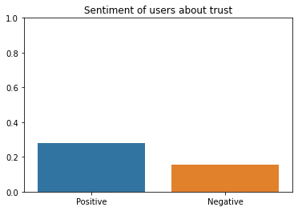Sentiment:

Figure 2: This shows how many people are positive or negative about this aspect

Figure 1: This shows Intensity of negativity or positivity of sentiments

### Inference:

### About 5% of users have written about trust on the app

### Out of which 50% users have suspicious view about the app while others are satisfied of its services

# 8.Covid-19 effect

* Percentage of users writing about this topic is 2.33%



* Average rating by these users = 3.57 of 5
* 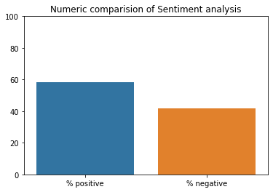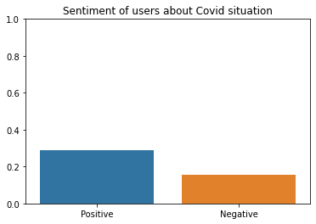Sentiment analysis:

Figure 2: This shows how many people are positive or negative about this aspect

Figure 1: This shows Intensity of negativity or positivity of sentiments

### Inference:

1. The services given by the app in covid-19 pandemic times are satisfactory completely
2. As, more than 80% of users are unhappy about the service provided in this period

### 